Performance Monitoring of Bridge-Track Transition Zones
Macy L. Purcell¹ , Jerry G. Rose¹, Tim Stark², Steve Wilk²

¹Department of Civil Engineering, University of Kentucky, Lexington, KY
²Department of Civil and Environmental Engineering, University of Illinois at Urbana-Champaign, Urbana-Champaign, IL

This report provides a description of the research performed by the University of Kentucky in conjunction with the University of Illinois at Urbana-Champaign [1] that focuses on the behavior of the transition zone surrounding the bridge and track interface. Research has been conducted with attention to several concepts. First, attention has been given to the design of the track transition, and the material components that are used in the track construction. This includes both materials specific to the site, such as subgrade, and materials introduced during construction and operation, such as ballast. Second, consideration has been given to the design of the bridge abutments and any retaining wall(s). Third, the performance and response to train traffic of each transition has been monitored though the use of accelerometers strategically placed on the ends of ties. These accelerometers measure the acceleration of the track as the wheel passes over the tie. The accelerometer data is then used to calculate vertical displacement of the track during traffic, as well as dynamic forces applied by the train.
These items are considered in the goal of producing a concept or model of what constitutes a well-performing transition. This model could be used in design to predict the performance of the transition based on materials used including subgrade, subballast, ballast, or ties, or the performance of the bridge abutments based on abutment or retaining wall design. Finally, the model could be used during operation as a prescriptive guide for maintenance practices, as a quality check on previous maintenance, or to develop a maintenance schedule.

Background and Preparation
Between June 2014 and January 2015, UK and UIUC jointly monitored four different bridge transition sites. Each site varied in age, track profile makeup, speed, and bridge abutment design. The four sites considered were:
- South abutment of the KY Dam Bridge on the Paducah & Louisville Railroad in Gilbertsville, KY.
- South abutment of the Calvert City Complex Bridge on the Calvert City Complex spur on the Paducah & Louisville Railroad in Calvert City, KY.
- North abutment of the Tennessee River Bridge on CSX Railroad in Bridgeport, AL.
- South abutment of the Ft. Branch Bridge on CSX Railroad just north of Evansville, IN.
These sites were selected because they provided a wide array of factors that influenced performance.
After receiving permission and obtaining track time, accelerometers were attached on top of the ends of selected ties in order to read vertical acceleration as shown in figure 1.
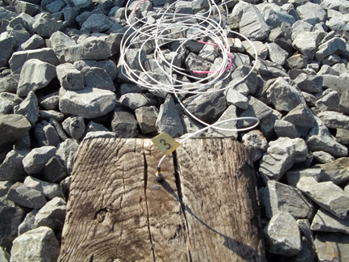
Figure 1. Accelerometers were attached on top of the ends of selected ties.
Typically, each tie under observation had an accelerometer on both sides of the tie.
Accelerometers were placed on the last tie of the bridge abutment, the first tie of the track, and on various ties in the transition zone leading up to the abutment. As distance from the abutment increased, so did spacing between the ties observed as shown in figure 2. This spacing was meant to show the response of the track as the train approached, and how performance varied as distance increased from the track-abutment interface.
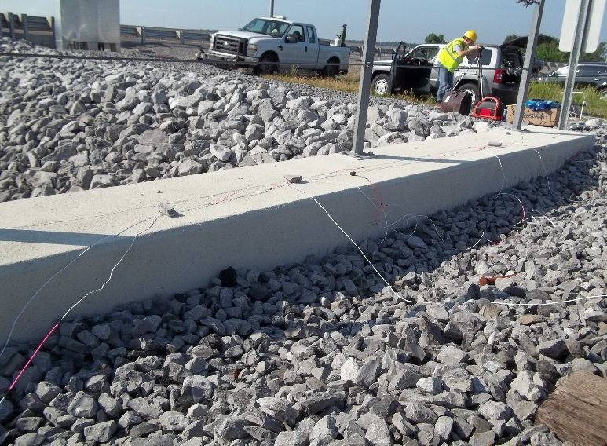
Figure 2. Accelerometers were attached to the abutment.
In addition to the accelerometers, a high-speed camera was used to directly obtain deflections in addition to the back-calculated deflections from accelerometer data (figure 3). The camera was mounted on a tripod about eight feet from the track, and a grid was fixed to the end of the tie. Typically, the tie used also had an accelerometer attached, in order to compare data. As the train passed over the transition, the camera recorded the movement of the tie, and the deflection could be determined from the movement of the grid.
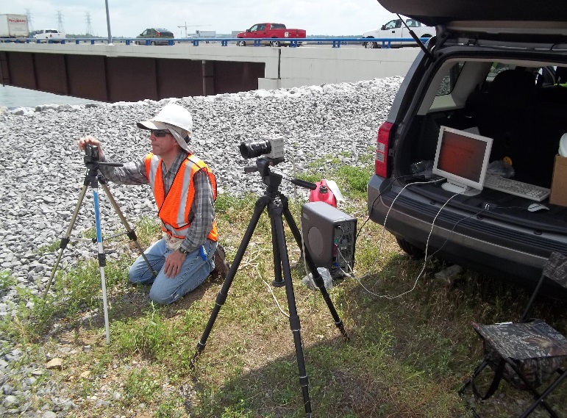
Figure 3. High-speed camera setup.

Observation and Data
Once the instrumentation was in place, data was collected from multiple trains at each site. Recording data required only the pressing of the record button on the camera and the clicking of the start button in the computer software for the accelerometers.
On average, data from 6-8 trains was collected during each site visit (figure 4 &5).
Data reduction was performed by UIUC. One of the primary results from data reduction was the acceleration of the ties as each wheel passed over, result is shown in figure 6.
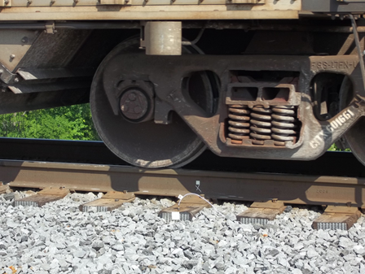
Figure 4. On site test.1
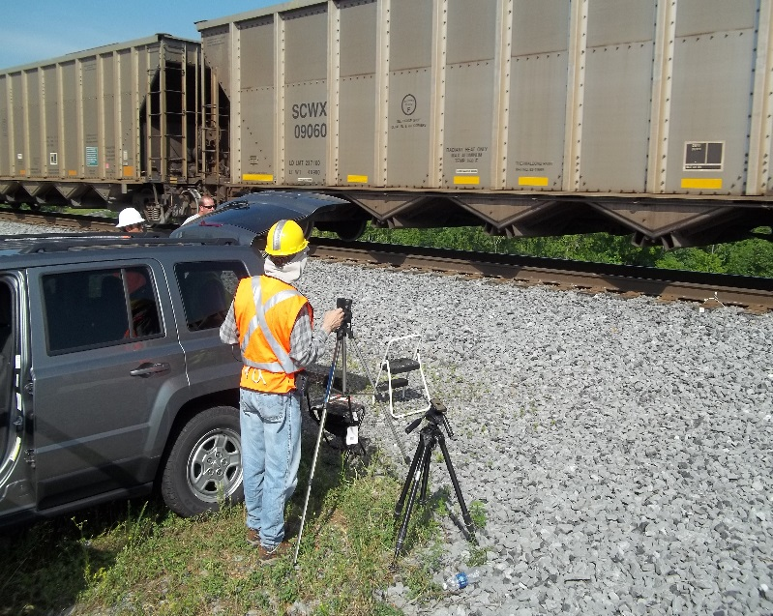
Figure 5. On site test.2
Figure 6. Acceleration of the tie from one test.
The second data of interest was the amount of transient and permanent displacement each tie underwent as trains passed by. Displacement calculations were done through double integration of the acceleration data.

Conclusions
The relevance of this research cannot be understated. Bridges and bridge transitions are critical points of maintenance and require special attention in order to maintain a safe and operationally efficient railroad. The key to ideally performing transitions is obtaining adequate trackbed support. If the substructure or trackbed of a transition is known, then it can be compared with acceleration data to determine its effectiveness. This is precisely what our research did. Physics dictates that force increases linearly with increasing acceleration. Testing showed that those ties that experienced the most transient and permanent displacement, experienced the highest accelerations. Thus, they also experienced higher forces. From a maintenance standpoint, these higher forces decrease the lifespan of the various track components, e.g. ties, rail, ballast, etc. The known trackbed support was important when comparing to these accelerations. Transitions with weak support, layers of inadequate depth, or large amounts of mud or standing water were not able to support the track, and in turn produced higher displacement of the track.
Preventive maintenance and suitable design are critical to well-performing bridge transitions. In the case of the KY Dam Bridge in Gilbertsville the design is critical to its continued success. The south embankment was built approximately three years before the bridge was constructed, allowing adequate time for settlement. In addition, the trackbed included a layer of hot mix asphalt. This layer contributed to the stiffness of the trackbed, and to the lack of displacement during traffic. To reduce or eliminate excessive forces in these transition zones, support must be sufficient such that it can resist displacement.

Reference
[1]. Rose, J.; Stark, T.; Wilk, S. and Purcell, M. (2015). Design and Monitoring of Well-Performing Bridge Transitions, Proceedings of the 2015 Joint Rail Conference, 9 pages.
The authors would like to thank the National University Rail (NURail) Center, a US DOT-OST Tier 1 University Transportation Center for sponsoring this study.

